Kenneth Miralles Mora – Badges - Credly

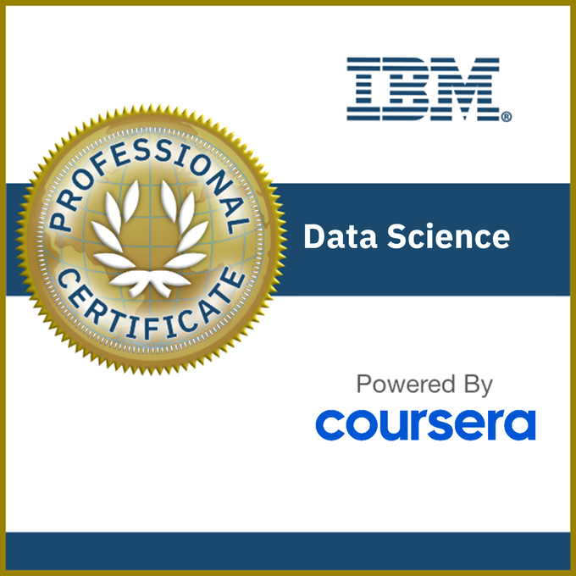
Earning Criteria
- Note: If you are just beginning this program, please refer to and follow the Version 2 Certificate program found at this link.
- Complete all courses in the IBM Data Science Professional Certificate program on Coursera (includes quizzes, hands-on assignments and projects), and earn the following badges:
- Data Science Orientation
- Tools for Data Science
- Data Science Methodology
- Python for Data Science and AI
- Databases and SQL for Data Science
- Data Visualization with Python
- Data Analysis with Python
- Machine Learning with Python

